DAY_5

What is build ?

Developer devlope the programe and all the programes integrated and make packaged format or an executable format called as build

Tester get build for testing not a programe

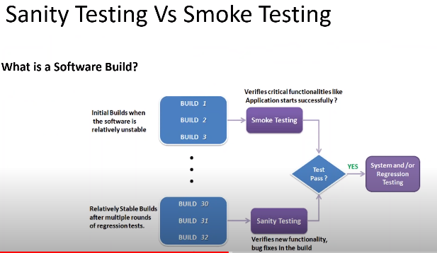

SMOKE TESTING

Once build received from developer. Check critical functionality of the system called smoke testing

Smoke Testing comes into the picture at the time of receiving build software from the development team. The purpose of smoke testing is to determine whether the build software is testable or not. It is done at the time of "building software." This process is also known as "Day 0".

In the smoke testing, we only focus on the positive flow of the application and enter only valid data, not the invalid data. In smoke testing, we verify every build is testable or not; hence it is also known as **Build Verification Testing.**

Smoke testing does not require to design test cases. There's need only to pick the required test cases from already designed test cases.

Eg.

1. Build installed or not

2. All the pages are properly or not

3. EX. Gmail verification

If we have Gmail application to test what are the important functions, login to Gmail, compose mail, and send, so for instant if there is an error sending mail doesn’t make sense to test send mail, draft etc.

4. EX 2

Try to access the ecommerce side and add item in your cart and place an order that’s a major workflow in most of the ecommerce site, if flow works then you can say build is pass then we move to the functional testing.

SANITY TESTING

What is Sanity Testing?

**Definition:**Sanity testing is a subset of regression testing. After receiving the software build, sanity testing is performed to ensure that the code changes introduced are working as expected .This testing is a checkpoint to determine if testing for the build can proceed or not.

Generally, Sanity testing is performed on stable builds and it is also known as a variant of [regression testing](https://www.javatpoint.com/regression-testing).

We can say that sanity testing is performed to make sure that all the defects have been solved and no added issues come into the presence because of these modifications.

Sanity testing also ensures that the modification in the code or functions does not affect the associated modules. Consequently, it can be applied only on connected modules that can be impacted.

**Description:**The main purpose of this testing is to determine that the changes or the proposed functionality are working as expected. If the sanity test fails, the build is rejected by the testing team to save time and money.

It is performed only after the build has cleared the smoke test and been accepted by the Quality Assurance team for further testing.

The focus of the team during this testing process is to validate the functionality of the application and not detailed testing. Let’s assume that in an e-commerce project, there are mainly five modules- like login page, home page, user profile page, new user creation, etc.

There is a defect in the login page when the password field accepts less than four alpha numeric characters and the requirement mentions that this password field should not be below eight characters. So, the bug is reported by the testing team to the development team to resolve it.

When the development team fixes the defect and passes it to the testing team. Then the testing team checks if the changes done are working fine. It also checks if it does not have an impact on other related functionalities. Now there is a functionality to update the password in the user profile page. As part of the sanity check, we would need to validate the login page as well as the profile page to ensure that the checks are working fine at both the places.

Sanity tests are generally performed on build where the production deployment is required immediately- like a critical bug fix.

